Steps

----

$ git init

$ git ls (to view all files in the directory)

$ git remote add origin https://github.com/NagoorMeeranHaji/Dummy_1.git (To map repository with local directory)

$ git remote -v (to know whetehr we have access for fetch and push)

$ git add . (to add files to repo)

$ git commit -m "First Commit"

$ git push origin master

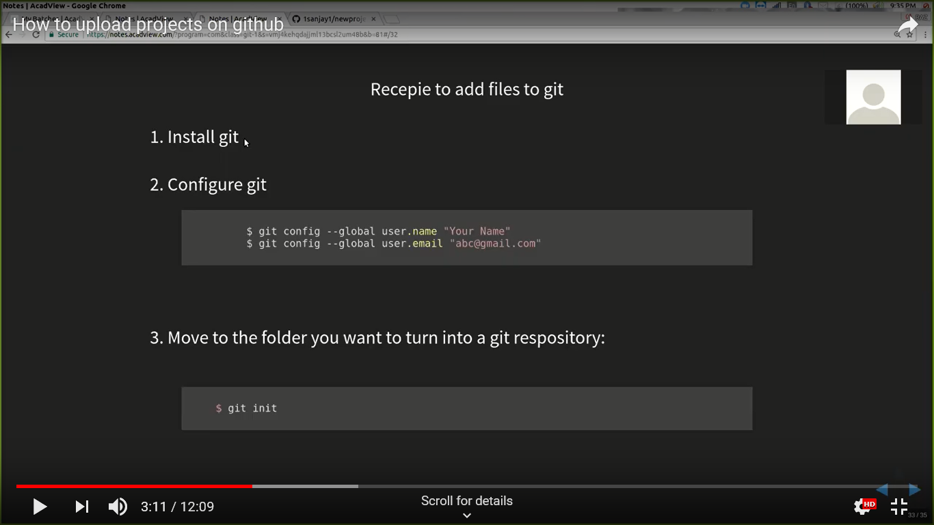

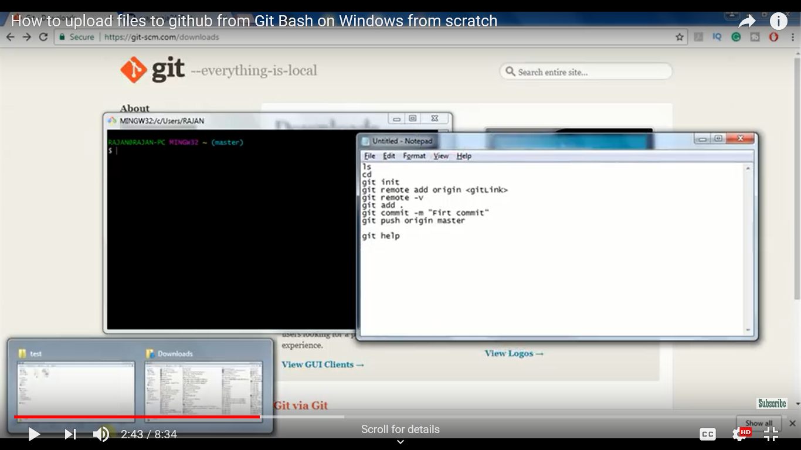

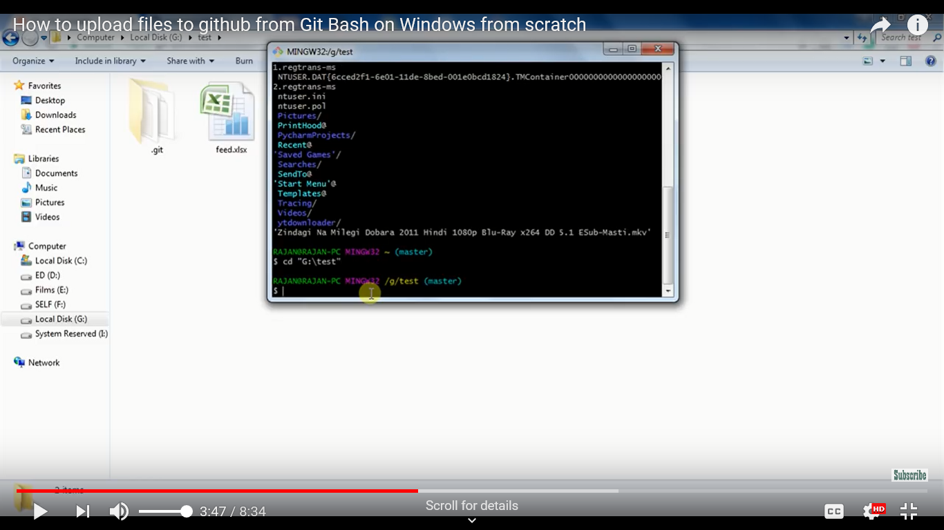

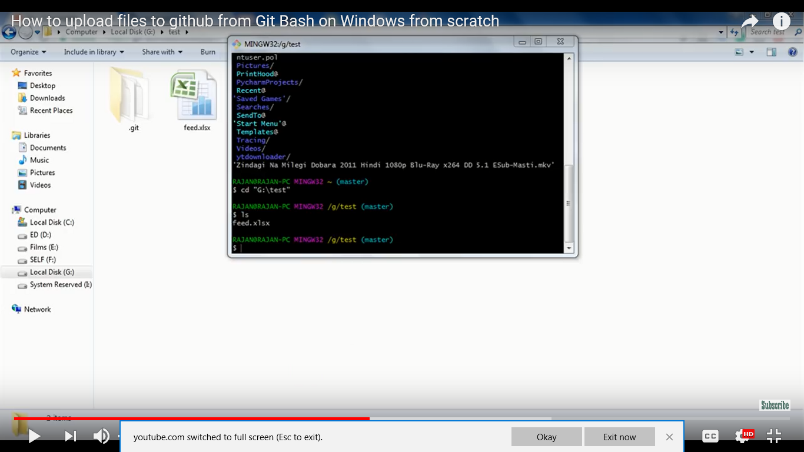

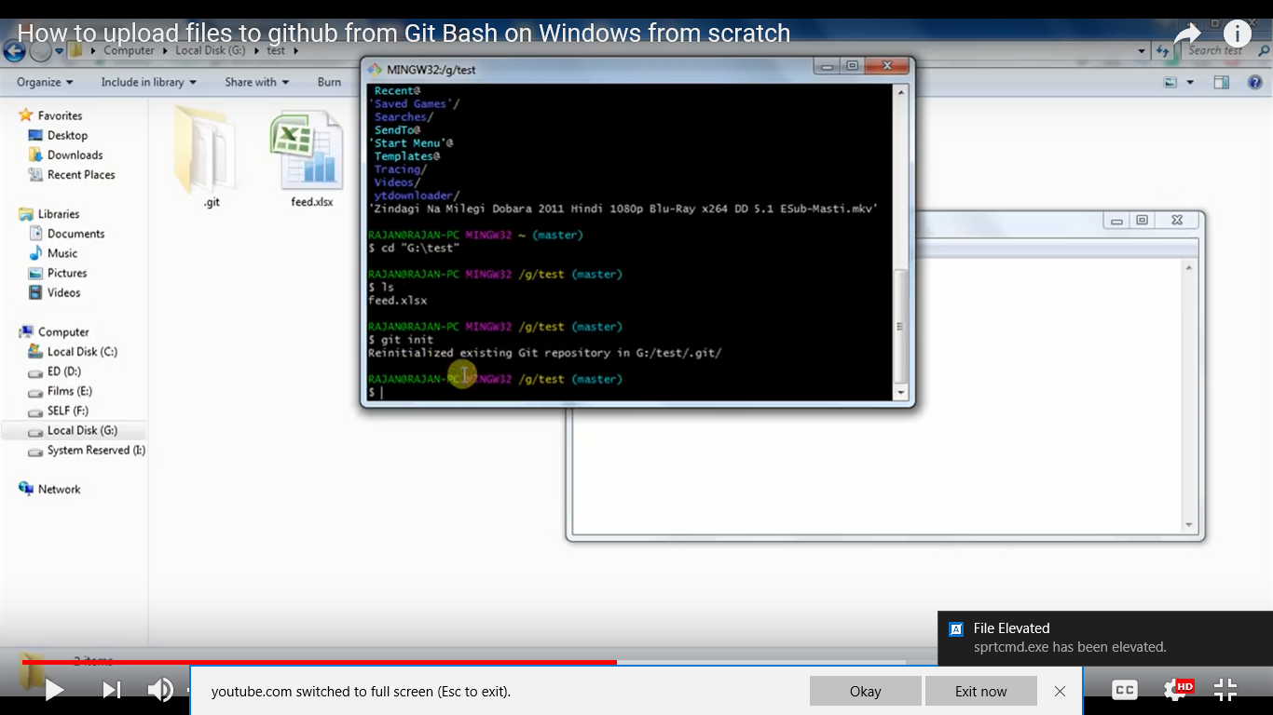

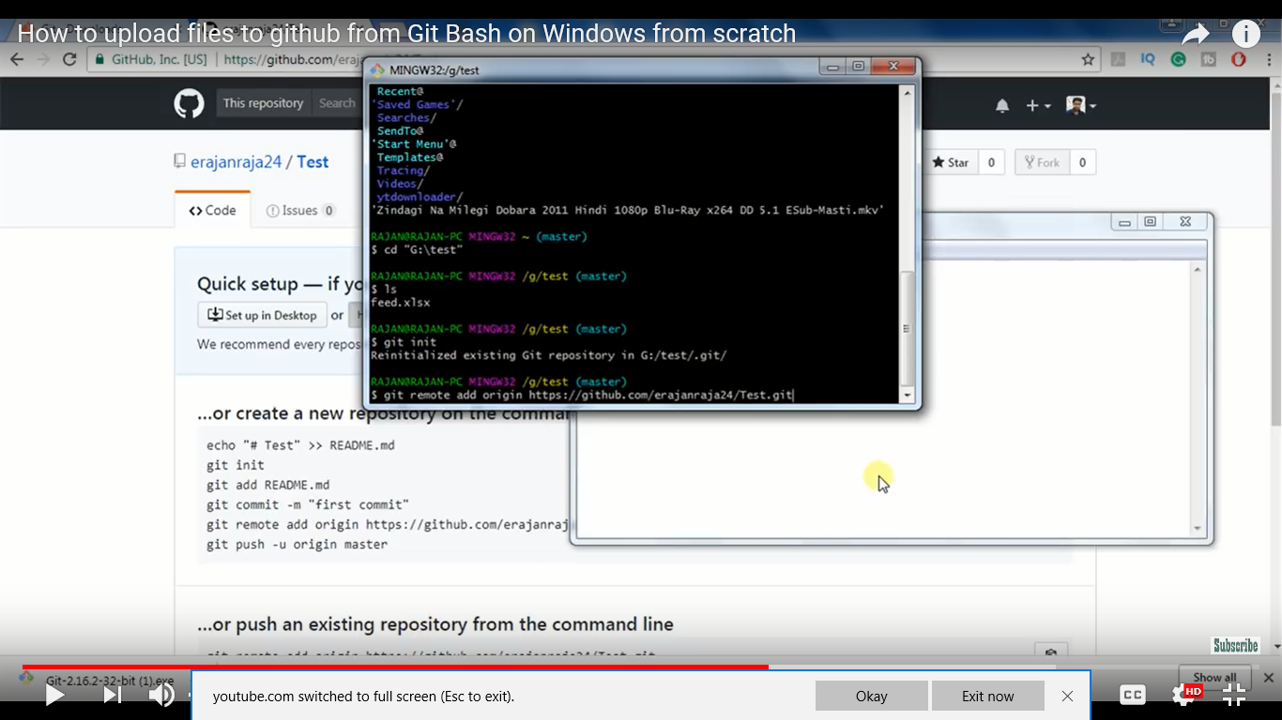

Check whether we have access to Push and Pull

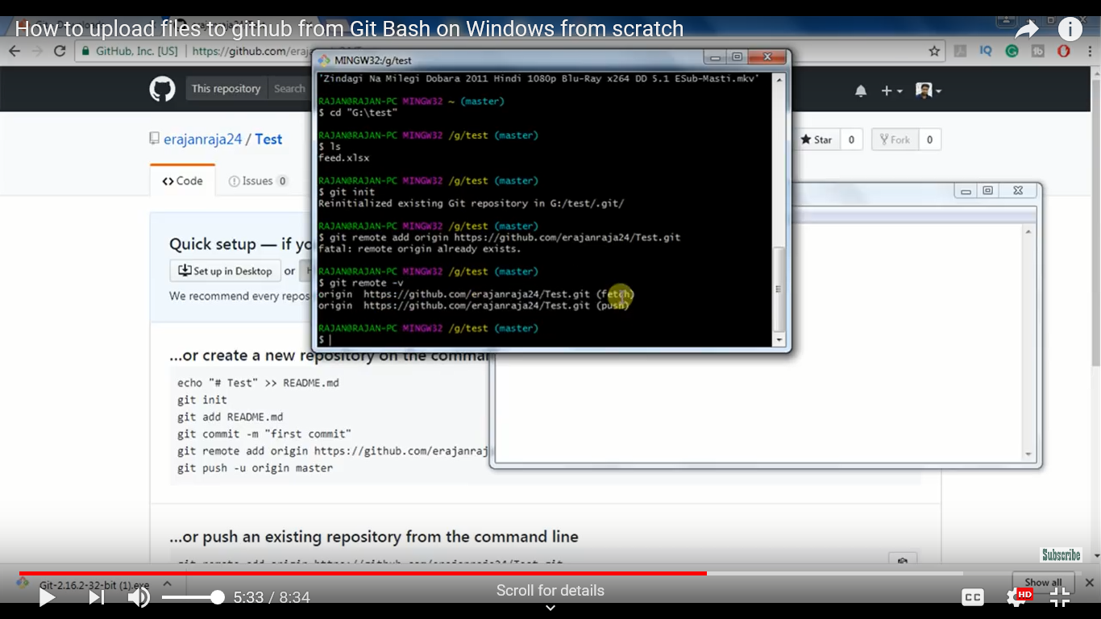

To add all files in a directory

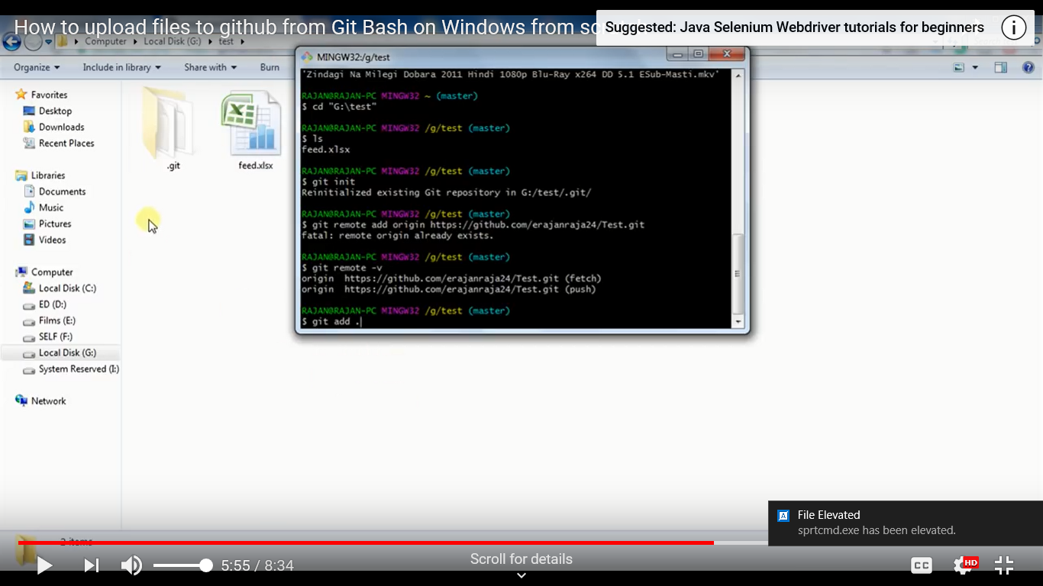

Add comments and commit

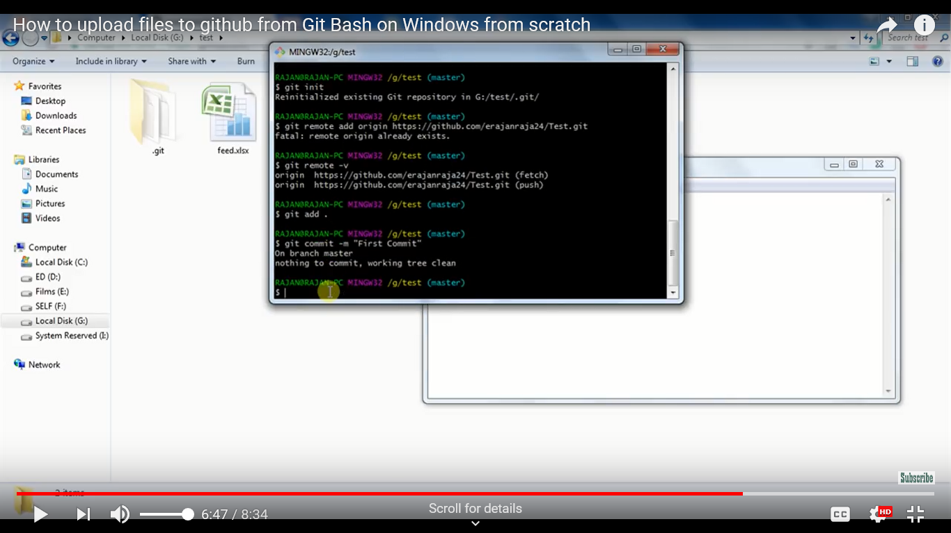

Push files to

